Insert Corporate logo

Business Continuity Plan

Enter Business name

Advice for completing this plan.

This following template is a simple plan and should be adopted and added to in order to suit your business and its activities.
The text in red is there to illustrate when specific company information should be added.

Table of Contents
Introduction 3
Aim of the plan 4
Objectives of the plan 4
Distribution List 4
Critical Functions 4
Business Impact Analysis 4
Business Impact Analysis Template 5
Emergency Response Checklist 7
Contact Lists 8
Staff 8
Key Suppliers 8
Key Customers 8
Utilities 9
Local emergency services 9
Insurance & Finance 9
Action & Expenses Log 10
Business Continuity Test 11
Business Continuity Test Report Template 12
Use of this template 13

Introduction

A business continuity plan will ensure that staff know their roles and responsibilities in the event of an unexpected incident and respond following a recognised and agreed procedure.

Business continuity planning is a proactive business process that lets a company understand potential threats, vulnerabilities, and weaknesses to its organisations in times of a crisis. By creating a plan this helps to decrease business downtime and outline steps to be taken, before during and after and emergency.

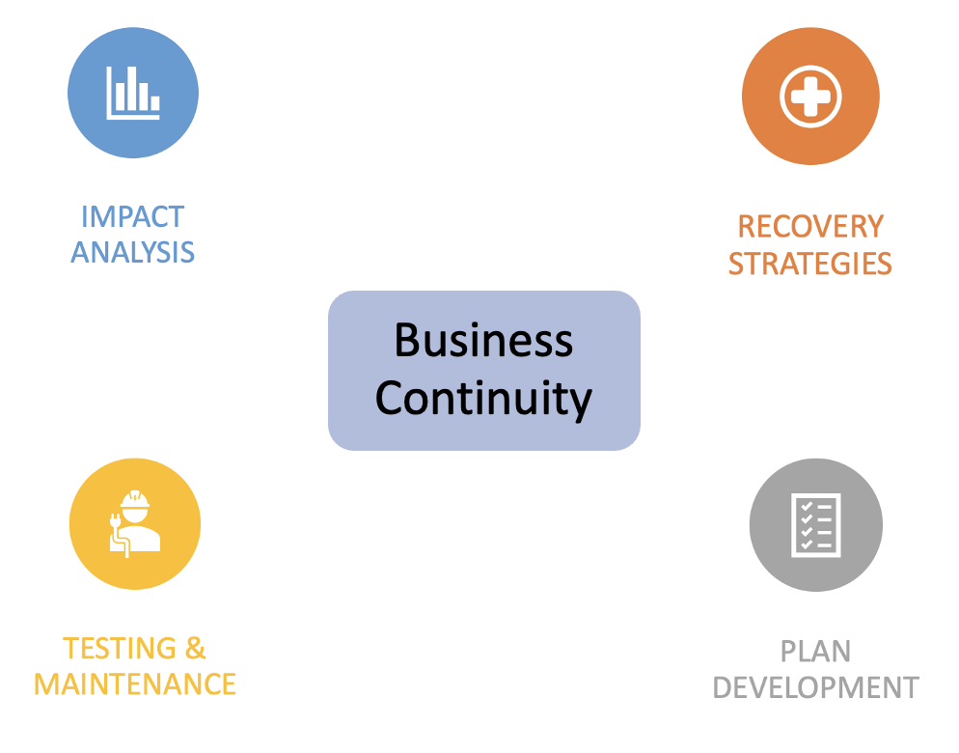

Aim of the plan
This plan has been designed to prepare [Business Name] to cope with the effects of an emergency. It is intended that this document will provide the basis for a relatively quick and efficient return to ‘business as usual’ regardless of the cause.

Objectives of the plan
The objective of this business continuity plan is to provide a flexible response [Business name] can:
- Respond to a disruptive incident
- Maintain delivery of critical activities/services/products during an incident
- Return to ‘business as usual’

Distribution List
This plan will be stored and available to the following people.

Copy Number | Name | Location
001
002
003
004
005
006

Critical Functions

Priority | Critical Function | Timeframe
1 | [Name of function or activity e.g., receiving orders] | [Recovery timeframe e.g., restore within 4 hours]
2
3
4
5
6

Business Impact Analysis
A business impact analysis (BIA) is the process of determining the criticality of business activities and associated resource requirements to ensure operational resilience and continuity of operations during and after a business disruption.

Business Impact Analysis Template

Critical Function 1

Responsibility | [Role responsible for leading on this activity, and any deputies]
Recovery timeframe | [How quickly must this function be recovered to avoid lasting damage]

Effect on Service
Time | Effect on Service
First 24 hours
24 - 48 hours
Up to 1 week
Up to 2 weeks

Resource requirements for recovery
Time | First 24 hours | 24-48 hours | Up to 1 week | Up to 2 weeks
Staff
(Numbers, skills, knowledge, and any alternative sources)
Data / Systems
(Back-up, recovery processes, staff & equipment)
Premises (potential relocation, or work from home options)
Communications
(methods of contacting staff, suppliers or customers)
Equipment
(key equipment, replacement process or alternative sources)
Supplies
(processes to replace stock & key supplies)

Critical Function 2

Responsibility | [Role responsible for leading on this activity, and any deputies]
Recovery timeframe | [How quickly must this function be recovered to avoid lasting damage]

Effect on Service
Time | Effect on Service
First 24 hours
24 - 48 hours
Up to 1 week
Up to 2 weeks

Resource requirements for recovery
Time | First 24 hours | 24-48 hours | Up to 1 week | Up to 2 weeks
Staff
(Numbers, skills, knowledge, and any alternative sources)
Data / Systems
(Back-up, recovery processes, staff & equipment)
Premises (potential relocation, or work from home options)
Communications
(methods of contacting staff, suppliers or customers)
Equipment
(key equipment, replacement process or alternative sources)
Supplies
(processes to replace stock & key supplies)

[Duplicate and complete as many as necessary]

Emergency Response Checklist
Task | Completed date & time | Completed by
Actions within 24 hours
Log of actions started & expenses undertaken

Liaise with emergency services

Identify any damage (include staff, premises, equipment, data, records etc.)

Identify functions disrupted

Convene response & recovery team

Provide information to staff (including what is required of them)
Provide information to key stakeholders (including what is required of them)
Provide information to public (if and as required)

Daly actions during recovery process
Convene response & recovery team

Provide information to staff (including what is required of them)
Provide information to key stakeholders (including what is required of them)
Provide information to public (if and as required)

Following recovery process
Arrange a debrief

Review & update Business Continuity Plan

Contact Lists

Staff
Name | Job Title | Office Contact | Mobile Contact

Key Suppliers
Name | Provides | Contact Number | Contact Email

Key Customers
Name | Services/Products | Contact Number | Contact Email

Utilities
Utility | Company | Contact Number | Contact Email
Electricity

Gas

Telecommunications

Water

Local emergency services
Service | Location | Telephone
Ambulance | Emergencies
Fire Service | Emergencies
Floodline | Information Service
NHS
Police | Emergencies

Insurance & Finance
Service | Company | Contact Number | Contact Email
Banking

Insurance

Payroll

Accountants

Action & Expenses Log
This form should be used to record decisions, actions and expenses incurred in the recovery process. This will provide information for the post recovery debriefing.

Date | Decision/Action taken | By whom | Costs incurred

Business Continuity Test
Business continuity plan testing is a method of identifying how prepared your employees are in case of an emergency. It is a risk-to-reality simulation in which employees work together to test the recovery plans in place.

Types of business continuity tests:
- Checklist review
Review coverage of plan, are there any areas for improvement or change

- Structured walkthrough
Review of all aspects of the plan, walking through different scenarios with staff

- Simulation test
Execute the plan based upon a specific scenario, without actual interruption

- Parallel test
Bring up an alternate off-site facility, without bringing down regular site

- Full interruption
Move processing from regular site to alternative site

The business continuity plan should be test regularly. The frequency of this should be determined by the company risk assessment.

Business Continuity Test Report Template

Exercise date |  | Exercise Duration
Exercise type |  | Brief scenario description
Staff involved |  | 3rd parties involved
Name of test lead |  | Test location

Exercise aim
Exercise objectives
1
2
3
Business continuity plan sections included
1
2
3
Exercise lessons learned
1
2
3
4
Improvement Actions |  | Responsible | By when
1
2
3
4

Use of this template

© The IASME Consortium Limited 2017

This document is made available under the Creative Commons BY-SA license. To view a copy of this license visit https://creativecommons.org/licenses/by-sa/4.0/

You are free to share and adapt the material for any purpose including commercial under the following terms:
- Attribution — You must give appropriate credit to The IASME Consortium Limited, provide a link to the license, and indicate if changes were made. You may do so in any reasonable manner, but not in any way that suggests The IASME Consortium Limited endorses you or your use (unless separately agreed with The IASME Consortium Limited)
- ShareAlike — If you remix, transform, or build upon the material, you must distribute your contributions under the same license as the original

Information contained in this document is believed to be accurate at the time of publication but no liability whatsoever can be accepted by The IASME Consortium Limited arising out of any use made of this information

